Assignment 2 – Normalization Michael Daly 040966083 Section 362

UNF:

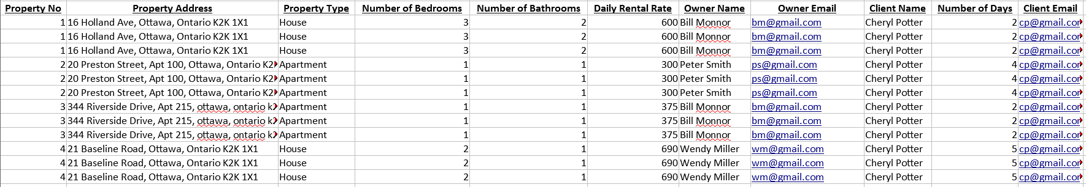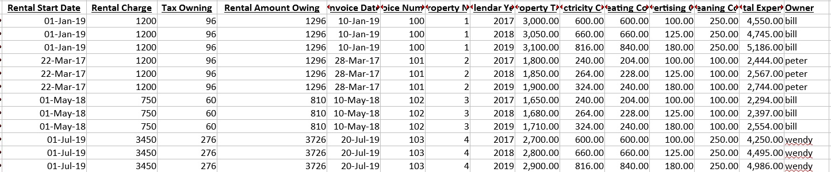

1NF:

Owner – owner name, owner email

Expense – property tax, electricity, heating, advertising, cleaning, total expense

Property – property #, property address, property type, # bed, # bath, rental rate

Client - client name, client email

Year – calendar year

Invoice – invoice date, invoice number, number of days, rental start date, rental charge, tax owing, rental amount owing

2NF:

Owner – owner name, owner email

Expense SK – property tax, electricity, heating, advertising, cleaning, total expense

Property – property #, property address, property type, # bed, # bath, rental rate

Client - client name, client email

Year – calendar year

Invoice – invoice date, invoice number, number of days, rental start date, rental charge, tax owing, rental amount owing

3NF:

Owner – owner id, owner name, owner email

Expense – expense id, property tax, electricity, heating, advertising, cleaning, total expense

Property – property #, Street, postal code, # bed, # bath, rental rate

Client - client id, client name, client email

Year – calendar year

Invoice – invoice date, invoice number, number of days, rental start date, rental charge, tax owing, rental amount owing

Property Type - property type id, property type

City – city_id, city

Province – province id, province

Country – country id, Country